**LAB 6 REPORT**

LITEC

Jordan Cabahug-Almonte

Jacob Montenieri

Kristen Weatherbee

Section 4B

Teng Liu

May 2, 2018

**Table of Contents**

**Introduction** **3**

Purpose 3

Objectives 3

Overview of Gondola Feedback Control 3

**Schematics** **5**

**Results, Analysis, and Conclusions** **6**

Description of Gondola Performance 6

Verification of Performance to Specifications 6

Analysis of plots from data 7

What was Learned 12

Problems Encountered and Solution 12

**List of References** **14**

**Academic Integrity** **15**

**Participation** **16**

# 

# 

# **Introduction**

## **Purpose**

This is the last lab we have completed throughout this course. The purpose of this lab was to be familiar with the compass and ranger pairing, the LCD keypad, the wireless serial link, and the Programmable Counter Array in a different setting (the Gondola). We also had to understand proportional and derivative feedback loops and how those constants affected the desired results.

## **Objectives**

There were four main objectives of this lab:

1. To become familiar with with the thrust fans and other hardware on the Gondola and see the similarities between that and the car.
2. To implement a proportional and derivative (PD) control based on readings from the compass and the ranger and use that to obtain a desired direction
3. To read the initial desired heading through a keypad and have it modified by readings off of the ranger.
4. To properly read the voltage off of the battery used by the Gondola.

To use all of these components of the Gondola, we split the code up into 3 parts: the steering control (using the PD control loop), changing the heading based off of the reading of the ranger, and reading the battery voltage. We integrated all of these parts and ran many test trials with different proportional and derivative gains. We plotted the data to find the proportional and derivative gain that would cause the Gondola to reach the desired heading in the shortest amount of time with no overshoot. The circuit in the Gondola used for the lab was nearly the same as Lab 4 (Figure 1). The only changes that were made were the ports for the corresponding crossbar that we used (0x25) and motors, .

## **Overview of Gondola Feedback Control**

For this lab there were multiple equations that we tested to see if they would give us the correct values back when tested from worksheet 11 and after going through multiple samples to see which equation was constantly correct. After acquiring the necessary equation we used this to control the thrust fan’s pulse width, and respectively, their motors. For this equation we used specific values such as the error and previous error in the desired heading vs. actual heading, the proportional gain, and the dampening gain. Using error as well as previous error allows us from overshooting to get to our desired heading more efficiently. Similar to this, our dampening gain helped take care of the overshooting in turning since the Gondola was on a turntable and was needed so that it wouldn’t just start spinning in a circle more quickly. Finally the last gain that we used was the proportional gain. Using this gain allowed us to have more thrust in the fans so that it wouldn’t stall or take a long time to get to the desired heading since we wanted to complete the goal quickly as well as accurately. One of the main challenges we had to face in the lab is figuring out the balance between the proportional and dampening gains since the two values are dependent on each other. If the proportion between the two is too great the Gondola could spin out of control or in the opposite scenario they could stop turning the Gondola but at the wrong spot if the values are too close together. One of the main challenges in this lab was implementing the used equation correctly and finding the right balance between the two gain values.

# **Schematics**

Figure 1: Schematic of the Gondola

# **Results, Analysis, and Conclusions**

## **Description of Gondola Performance**

The code implemented in the Gondola detected an object within 100cm of the ranger. When the object was farther than 50cm away then the Gondola would spin clockwise until the maximum offset of 180 degrees of the desired heading was reached. If the object was closer than 50cm then the Gondola would spin counter clockwise until the maximum offset of -180 degrees of the desired heading was reached. If the object was 50 cm away, the Gondola would maintain the desired heading entered. Only one of the side fans would be running at a time and this was dependent on where the Gondola’s compass was pointing in relation to the heading. If the desired heading was closer to the Gondola’s compass to the right of the Gondola, the right fan would run to get to the desired heading. If the desired heading was closer to the Gondola’s compass to the left of the Gondola, the left fan would run to get to the desired heading. If the Gondola passed the desired heading, then the one fan that was running would turn off and the other fan would start running.

In the first few moments of running the code, the Gondola would oscillate clockwise and counterclockwise aggressively. If the gain constants used were ideal, the Gondola would start oscillating less towards the desired heading and eventually stop as the oscillations decreased. Once the Gondola’s desired heading or the desired heading with the offset from the ranger was reached, both side fans stopped. When there was a draft, one fan would start running to oppose the draft but the fan would be running slow enough to keep the Gondola at the desired heading.

The performance of the Gondola relied heavily on if all the components of the Gondola were working. In some of the Gondolas, the compass was not calibrated or functioning properly. This affected the Gondola’s performance results. The Gondola would not perform well if the any of the motors were not working properly, such as if they were going in reverse or just not running. The orientation of the thrust angle affected the Gondola performance as well. If the thrust motor could only be turned one way so that the fans were perpendicular to the ground and that way was different than how we had it last, we had to change which side fans turned on and which side fans turned off by changing which CEX pulse widths we manipulated during certain conditions.

Overall, the Gondola did perform as required in the lab. The Gondola’s performance met all of the lab’s objectives when the gains were optimal and all the equipment was functioning properly.

## **Verification of Performance to Specifications**

In this lab, we implemented a PD control loop that turned the Gondola to a desired heading when an object is placed 50cm above the ranger. We had to ensure that all of the equipment in the Gondola was working. With code from Lab 3, we tested if the compass was reading headings from 0 to 3600. Then we tested the rudder angle with code from Lab 3 to turn the thrust motor so that the side fans were perpendicular to the ground. This ensured that the compass and the thrust motors were working.

Before we used the ranger, we only dealt with the PD control loop without any offsets of the desired heading to find the optimal proportional and derivative gain. We tested several cases by lowering and raising both gains. If the derivative gain was too high and/or the proportional gain was too low, the Gondola would take too long to reach the desired heading or not be able to reach the desired heading at all due to the drag in the room. If the proportional gain was too high and/or the derivative gain was too low, the Gondola would oscillate too much or just spin around uncontrollably. We found the optimal gains were a proportional gain of 1 and a derivative gain of 3. These desired gains gave a critically damped results, showing minimal oscillations in our plots.

After we verified that this part of the lab worked, we implemented the ranger to create a max offset of 180 degrees to the desired heading. When the object above the ranger was farther than 50cm away, the Gondola turned clockwise until it reached the desired heading’s maximum offset. When the object above the ranger was closer than 50cm away, the Gondola turned counterclockwise until it, again, reached the desired heading’s maximum offset. We tested this part of the lab by raising and lowering a book above the Gondola’s ranger.

## **Analysis of plots from data**

After completing the lab we decided to run three trials that would show how the damping and gain constants affect the control of achieving a actual heading close to our desired heading. Since the Gondola was on a turntable this made the lab more challenging since the Gondola would continue to turn even when both of the thrust fans were off. Since we had this issue the only way to solve it was have the fans oscillate so that the actual would get close enough to the desired heading.Running our three trials we used constants that we knew would work for the first trial and purposely used invalid gains to skew our results to show the effects of a system that doesn’t have enough damping and one that has too much.

For our first trial, as mentioned above, we used the values for the damping and proportional gain that allowed us to complete the Lab. Finding these values was simply just testing out multiple values for each gain until we found the two that worked best together, which in our case was a damping gain of 3 and a proportional gain of 1. This allowed the Gondola to quickly, but accurately, change the actual heading to the desired heading. As seen in Table 1 the actual heading does start very far away from the desired heading and quickly closes the gap but does slightly overshoot the desired heading. Fixing this it turns on the other fan and slowly gets closer and closer to the desired heading by alternating fans until it is close enough to the desired heading. As shown in Graph 1 this is represented extremely well due to the fact that the amplitude of each wave begins to dampen for the actual heading until it is in line with the desired heading.

For our second trial we decided to use a higher damping gain than what proved to be useful to see how it would affect our results. Since the damping gain is in control of slowing the fans speed down before reaching the desired heading, we predicted that this would cause the actual heading to never reach the desired heading or if it did simply over a long period of time. As we predicted, Table 2 shows that the actual heading was slowly inching towards the desired heading but never reached it to an accurate degree. Even if this was to reach the desired heading the results could be unpredictable and we were asked to not create an overdamped cycle but instead one like we had in the first trial. Similarly shown in Graph 2, the actual heading barely makes any progress towards reaching the desired heading.

For our third and final trial we decided to use a higher proportional gain to see what the result would be. Since the proportional gain is in charge of the magnitude of the fans thrust power, this gain would more than likely cause the fan to increase speed over time to the point where the Gondola would be just spinning in a circle. While the data is somewhat difficult at portraying this, this is what happened by having too much of a proportional gain. As seen in Table 3 the actual heading changes very sporadically but what is actually happening is that the Gondola is spinning in circles and our degree value resets once it passes 3599 so the values would jump from 2002 to 610 because it went to 3599 and reset back to 0 to then go to 610. Again this is hard to show but it can be understood in Graph 3 where the actual heading would peak at a high value and then drop off to a low value and begin to climb again. Overall these tables and graphs showed us how each gain works independently and how they are used together to help us complete the lab.

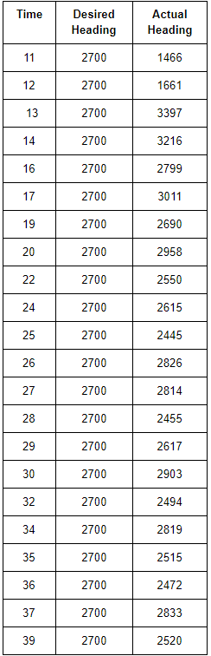

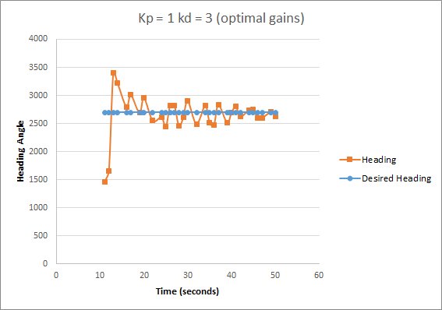

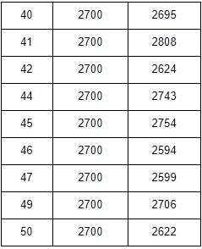

Graph 1: Graph for optimal gain values in Trial 1

Table 1: Optimal gains (kp = 1) were set for Trial 1

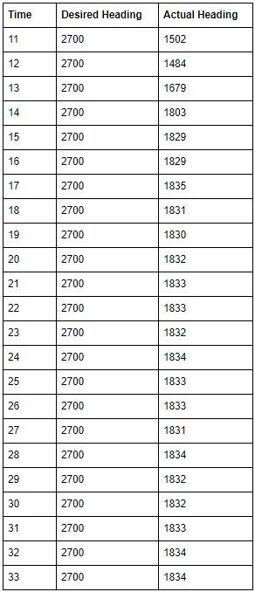

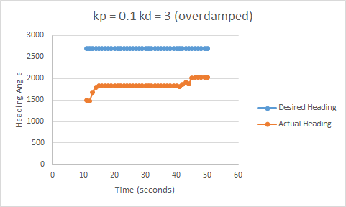

## Graph 2: Graph for overdamped Trial 2

Table 2: Table for overdamped (kp = 0.1) Trial 2

Table 3: Table for underdamped (kp = 15) Trial 3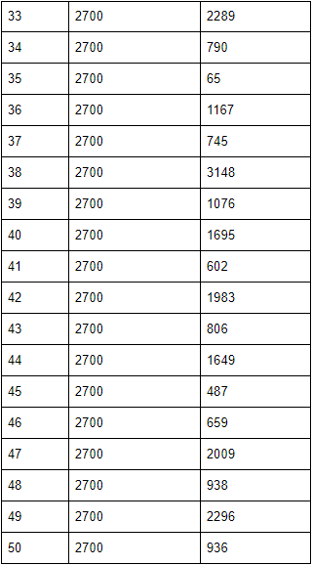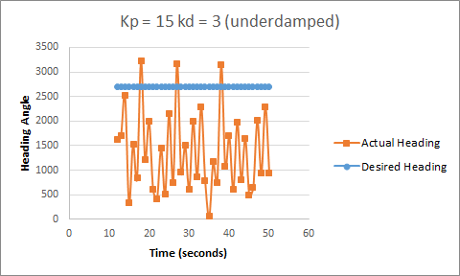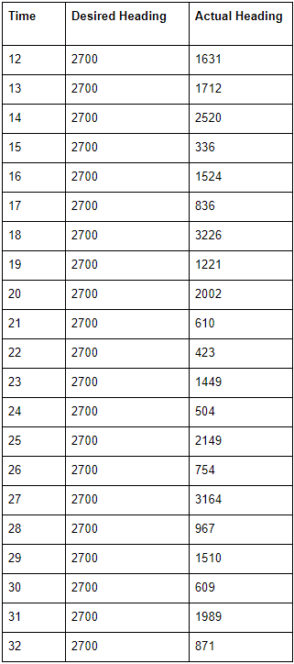

## **What was Learned**

Through this lab, the main takeaway was learning how to use proportional and derivative feedback control to allow the gondola to move towards the desired heading quicker and more accurately. More specifically, the proportional gain is calculated from a position based error while the derivative gain is calculated from a velocity based error. In other words, the derivative gain considers the rate of change of error and tries to bring this rate down to zero (or a horizontal line). This process is adding damping to the system therefore reducing overshoot. However, too much damping while the error was small would also cause overshoot so in attempt to correct the original overshoot the large correction in the opposite direction would oftentimes be too much and cause the gondola to oscillate, repeating this process over and over. On the other hand, too little damping would cause the gondola to oscillate or keep spinning while the overshoot was not corrected enough.

Along with derivative and proportional feedback control, we learned how to use the gondola and several components with the gondola such as the compass and ranger. We learned how to set the thrust angle and thrust power for the two thrust fans. We also learned how to use the compass with the gondola to move towards a desired heading. Once we were able to get the gondola to accurately stop at a desired heading, we were able to learn about how to use the ranger with the gondola. The ranger input was eventually used to modify the desired heading. By the end of the lab, we were able to use the gondola combined with the compass, ranger, and LCD Panel while adjusting the pulse width for the two motors and thrust angle for the thrust fans.

## **Problems Encountered and Solution**

We encountered several problems during this lab. The first problem we ran into was that our thrust fans were going from a neutral pulse width right to the maximum pulse width when the pulse width was supposed to gradually get higher and higher. This caused overshoot regardless of the gain values, resulting in the gondola spinning out of control. To solve this, we noticed when we set the thrust angle to vertical, we had the fans flipped by 180 degrees and we had to flip them back to make sure they were lined up correctly. Once this was done, we had to make sure we were setting the pulse width for the correct fan. Once these changes were made, the correct fans were turning on with the correct pulse width.

Another problem we had involved the previous error. After trying several different gain values, we were noticing the gondola did not seem to be recognizing where the desired heading was. We were getting random values for the calculated pulse width for the fans. After looking further into the equation that calculates the pulse width, we found that we had set the previous error variable to an unsigned integer. Once we changed this variable to a signed integer, the calculated pulse width values were correct.

Another issue we were encountering was with the proportional gain and derivative gain. As mentioned before, too high of a derivative gain would cause overshoot and cause oscillation while too low of a derivative gain caused either oscillation or spinning. So we had to find a derivative gain that was not too big and not too small to avoid these problems. We also had to have a relatively small proportional gain because a larger gain would cause overshoot as well. To solve this, we found that a proportional gain of 2 and a derivative gain of 3.3 worked best.

A smaller issue that we ran into was with the compass. Not only did we have to calibrate it several times during one lab session but we also had trouble getting accurate compass values because of the magnetic field. To fix this problem, we had to continue to calibrate the compass while moving the gondola to different spots on the table to find a magnetic field with the least noise to get the most accurate compass readings.

# 

# **List of References**

RPI-ECSE. (2017). Laboratory Introduction to Embedded Control Lab Manual v14.8. Troy, NY.

# **Academic Integrity**

All the undersigned hereby acknowledge that all parts of this laboratory exercise and report, other than what was supplied by the course through handouts, code templates and web-based media, have been developed, written, drawn, etc. by the team. The guidelines in the Embedded Control Lab Manual regarding plagiarism and academic integrity have been read, understood, and followed. This applies to all pseudo-code, actual C code, data acquired by the software submitted as part of this report, all plots and tables generated from the data, and any descriptions documenting the work required by the lab procedure. It is understood that any misrepresentations of this policy will result in a failing grade for the course.

The following signatures indicate awareness that the above statements are understood and accurate.

__________________________________________ Date: ________________

__________________________________________Date: ________________

__________________________________________Date: ________________

# **Participation**

Hardware implementation

Wiring _______________________________________

Pin-out sheet _______________________________________

Circuit Schematic _______________________________________

Software implementation

Pseudo-code _______________________________________

Code _______________________________________

Debugging _______________________________________

Data analysis

Data collection _______________________________________

Graph analysis _______________________________________

Report development and editing

Creating graphs _______________________________________

Editing and Formatting

Report _______________________________________

*The following signatures indicate awareness that the above statements are understood and accurate.*

___________________________________________________Date___________________

___________________________________________________Date___________________

___________________________________________________Date___________________